This project is an Internet radio application, users can use this application to listen to some Internet radio channels, including music, crosstalk, news, etc. (the radio information is transferred from the official API of open platform of Himalayas).This application is mainly to adapt to the network environment, for the traditional radio to provide a new way of life. At the same time, it is also to adapt to people's lifestyle in the environment where smart phones are fully popularized and enrich people's spiritual life. After observation, now the Internet radio application market is active, the main platform is the Himalayan platform, and the number of radio application downloads under this platform is huge, only in the Huawei application market has reached 2 billion downloads, it is worth trying.

The following is the code description: first is the environment construction, the application calls the Himalayas open platform SDK is stored in the jniLibs folder. Because the SDK only provides the relevant files of arm64-v8a and armeabi, it cannot run properly on the x86 emulator. The demo runs on the real machine, and the release folder in the code package will also hold the application installation package

1. MainFragmentActivity. Java: source file is the starting point of the program,

A) onCrete () : initialize and call the mobile audio player;

B) initView () : load the main layout act_main.layout, and add listening to the list DEMAND and LIVE.Call the phone audio player and display the playback interface and Settings.

C) onOptionsItemSelected () : different event Settings for the two playlists

D) onCreateOptionsMenu() : create a playlist

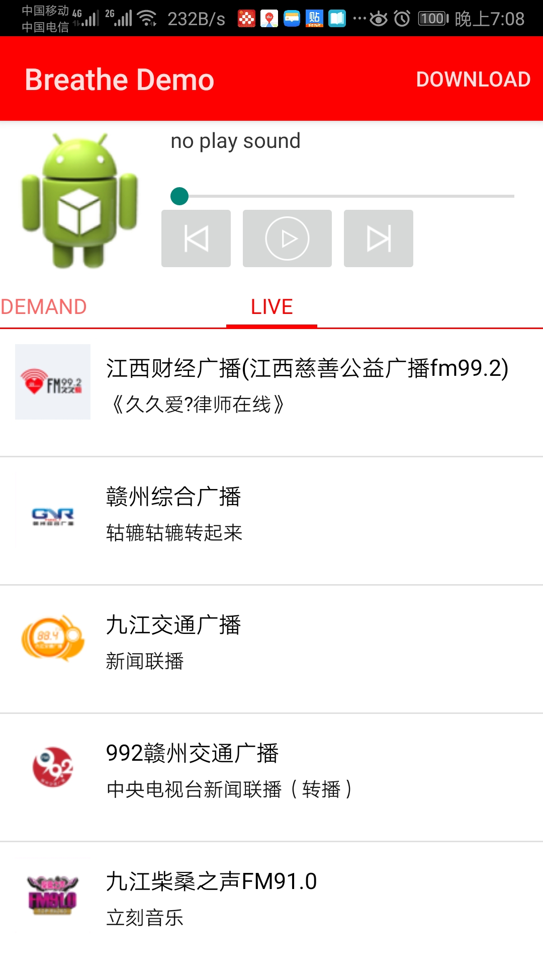

2. Tingapplication.java: this source file invokes the API and implements real-time audio playback

3. The fragments package:

A) RadiosFragment. Java: real-time radio playback function;

I. Class RadioAdapter: basic information, number of radio stations.

Ii. loadData () : data load playback

B) tracksfragment. Java: play audio files cached by the server;

I. Class TrackAdapter: basic information of audio files, number.

Ii. loadData () : data load playback

4. Download package: download is supported

A) BatchDownloadActivity. Java: batch download function

I. class BatchDownloadTrackAdapter: batch download class, realized the function of bulk download

B) downloadactivity.java: download function

I. Class MyPageAdapter: download the number of interface elements

C) downloadedfragment. Java: download to complete the interface operation

I. onActivityCreated () : supports sorting and deleting downloaded files

D) DownloadingFragment. Java: interface operation in download

I. OnActivityCreated () : support for pausing and deleting during download

E) DownloadTrackActivity.Java: download interface

I. DownloadTrackAdapter: information about a list of files that can be downloaded





5. Util package: a tool kit